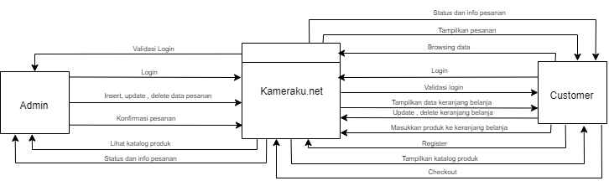DFD LEVEL 0 / DIAGRAM KONTEKS